(Approx. 1,645 words)

Drive for Change - Installing a Laptop Hybrid Drive
By Greg Skalka, President, Under the Computer Hood UG, CA
June 2015 issue, Drive Light
www.uchug. org
president (at) uchug. org

Like people, computers have a lifecycle. That lifecycle typically takes them from a youth of peak capabilities, through a middle age marked by a slowing down and perhaps reduced desirability to twilight years of diminished capacities, failing parts and obsolescence in the workforce. If your laptop is in the midst of a mid-life crisis, there are things you can do to turn back the clock and return a bit of that youthful capability and desirability.

I have a couple of laptops that are now three years old and don’t seem as quick and capable as when I bought them. I buy on a value budget, so both the Fujitsu Lifebook LH531 for me and Lifebook AH531 for my wife were mid-priced computers bought on sale. Both had decent processors, Windows 7, adequate but not expansive RAM and hard drives and the typical interfaces of the 2011 computer era. They now seem a bit slower, are running out of storage space and don’t have some of the new, faster interfaces to match my new accessories (like USB3). Should I continue to use them as they continue to slowly degrade, buy updated new replacements or upgrade them to add increased life and utility?

Fortunately, improvements in technology have led to falling prices in RAM and mass storage since I bought these laptops. I recently changed their RAM, doubling the amount in them from the original 2 GB, for a lot less than I probably would have paid for more memory three years ago. Now I’m looking at changing the 500 GB hard drives they came with to larger and/or faster mass storage.

It seems to me that these are constants in the computer user experience:
- You can always use more storage space
- The computer can always be faster

As luck would have it, available sizes for hard drives have been steadily increasing over the years as the-per unit cost of storage has been falling. In addition to magnetic spinning platter drives, solid-state drives (SSDs) are now available; these have much faster access times and can greatly decrease boot times and improve the performance of storage-intensive computer activities. Like hard drives, SSDs have also increased in size and dropped in price over the years. Unfortunately, the price drops have been proportional, so as SSD costs have come down to make them more attractive, so too have hard drive prices, so the choice for me has not been an easy one. Increasing my storage to a 1 TB hard drive in these laptops would now cost only about $60 each, but
a 1 TB SSD is currently around $300. I could speed things up with a 240 GB SSD for around $100, but would then have less than half the storage space I have now. It does not look like SSD prices are going to drop dramatically compared to magnetic hard drives and put them out of business anytime soon.
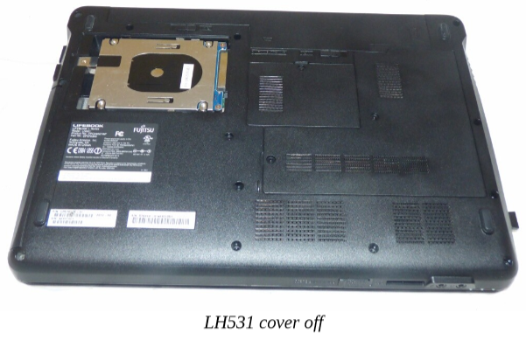
A new class of mass storage promises to provide the best of both worlds - large storage at a low cost, with much faster access times. It is called the hybrid drive or solid-state hard drive (SSHD), and it combines a magnetic platter hard drive and solid-state Flash memory in one device. With the addition of 8 GB of NAND Flash to the hard drive’s controller card, the most often accessed data is stored in the solid-state memory, reducing access times for a lot of critical disk operations. Now two of the three hard drive manufacturers, Toshiba and Seagate, offer these hybrid drives (so far Western Digital does not). Seagate claims their SSHD can boot in 22 seconds, when compared to an HDD (hard disk drive) boot of 37 seconds and an SSD boot of 21 seconds. A 1 TB hybrid or SSHD is currently available for around $80, which is not much more than an HDD, but a lot less than an SSD of the same size.

For my wife’s laptop, I recently installed a Toshiba MQ01ABD100H 1 TB hybrid drive. It doubled the storage space, while reducing the boot time from 90 seconds to 33 seconds on average. For my LH531 laptop, I’m choosing a Seagate ST1000LM014 1 TB hybrid drive. The process I used to change drives was:

1) Clean up the old drive. There is no sense in copying temp files, out of date applications or malware to the new drive. After running my anti-virus and anti-malware software and updating my operating system and important applications, I also defragmented the old hard drive.
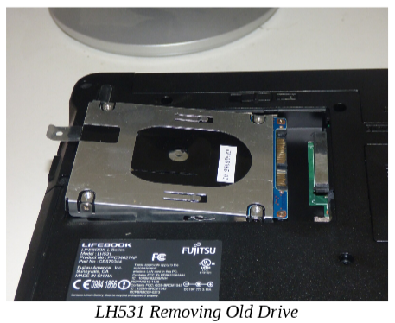
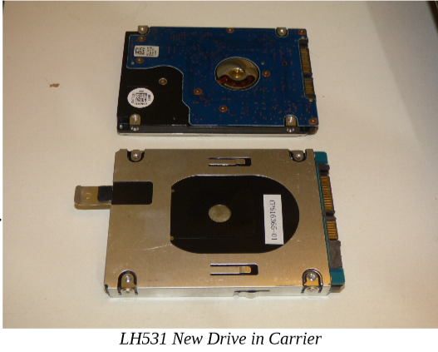
2) Back up the old drive. There are several ways to copy the data from the old drive to the new drive, including connecting the new bare drive to the computer through an adapter and running drive cloning software. I chose to instead make an image backup of my old drive to an external USB hard drive, and then later restore to the new drive after swapping them.
3) Remove the old drive and replace with the new bare drive. This is fairly easy on most laptops, though you do need to take care to avoid damaging the drive and computer from a static discharge.
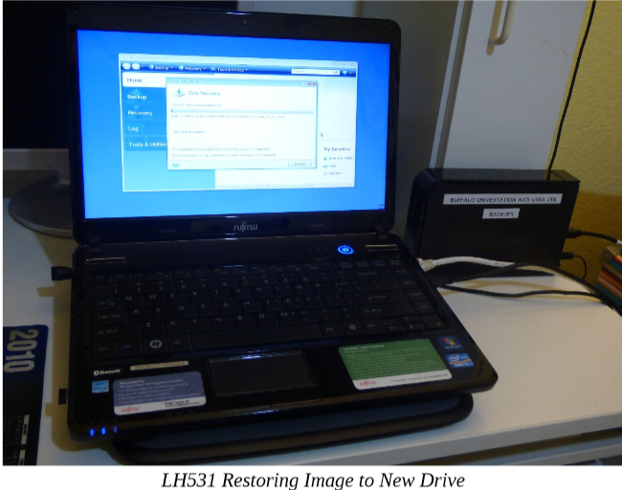
4) Restore the image backup to the new bard drive. With no operating system on the new drive initially, your backup program must be able to be booted from an external drive (a CD, USB or network drive).
5) Adjust the restored partition(s) on the new drive to take advantage of the additional space, if necessary.

The nice thing about this transfer method is that it is low risk - the original hard drive can always be installed back in the laptop should something go wrong in the transfer process.

I use Acronis True Image backup software, and so used it to make my image backup files for the transfers. Though True Image may be installed on the hard drive, it may also be run from the program CD, as the CD is bootable.

I always run True Image from the bootable CD as I want to be familiar with the way I would need to run it if I ever had a hard drive failure. Though I buy the new version of True Image each year (the latest is True Image 2015), I typically continue to use the older versions on my old computers, as I’m more familiar with the user interface. I found I had to move up to True Image 2014 when restoring to the hybrid drive in my wife’s laptop, as the 2011 version I used to make the backup image did not recognize the hybrid drive.

Note that I tried unsuccessfully to use True Image 2015 for the restore; I found this latest version did not recognize the external USB drive containing my backup file. True Image has had extensive and useful support for external and network drives in their previous versions; it appears Acronis may have traded that for cloud storage capabilities in their latest version.

While True Image can back up and restore individual files and folders, its main advantage over other backup programs is in making image backups of drive partitions (the partition data plus the partition formatting). I had True Image create a single backup file containing all the partitions on the old hard drive to make restoring to the blank drive easier.

Once the backup of the original hard drive was created, I flipped my laptop over and opened the small door over the hard drive. To remove the hard drive, I had to lift one end slightly and gently rock that end of the drive while pulling away from the connector, in order to disengage the drive from the laptop connector. The old drive was mounted in a metal carrier, which had to be removed and installed on the new hybrid drive. The procedure was reversed to install the new drive. The only tool needed was a small Phillips screwdriver.

Booting from the True Image 2014 CD, I restored the full disk image I had made from the original drive to the new drive. True Image proportionally increased the sizes of most of the partitions in my image file, so that all the new hard drive’s space was allocated among them. I then used another Acronis program, Disk Director 12, to resize some of the partitions to suit my needs.

Before I’d removed the old hard drive, I’d started the laptop repeatedly to measure the boot time. I repeated this with the new hybrid drive, and found that the boot time went from around 90 seconds to around 35 seconds.
LH531 Restoring Image to New Drive
The new hybrid drive has much more space and seems to provide a big speed improvement. Only one question remains - should this hybrid drive be defragmented? In a magnetic hard drive, the normal file write and erase operations result over time in files that are not stored in contiguous tracks on the disk, but have portions spread over many parts of the disk (the file is fragmented). In a spinning platter drive, this increases the time required to read the file (the read head must move more and often wait for the data to rotate under the head), so the drive should be defragmented periodically for optimum performance. The same fragmentation occurs in an SSD, but since the read speed is the same for every memory location, the access time is not increased, making defragmentation unnecessary. In fact, an SSD drive should never be defragmented, as this reduces the drive’s lifetime unnecessarily (each SSD location supports a fixed number of writes). I’ll need to consult with Seagate and Toshiba to determine if SSHDs should be defragmented.

